Data for this exercise: <https://drive.google.com/file/d/1_Zgi73vysPOzmVxziEiA5Fu7n_QPRZ1H/view?usp=sharing>

1. **Question:**

From the given data, find the average score of each student and check whether they are qualified or not. Qualification criteria is if average score is more than 75 then qualified for the next round or else not qualified

**Answer:**

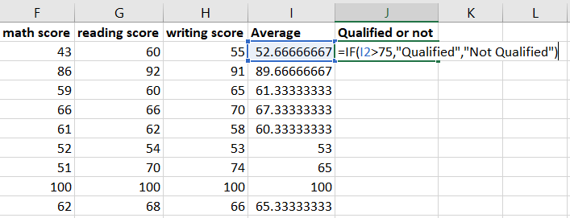

<press enter> and drag till last record

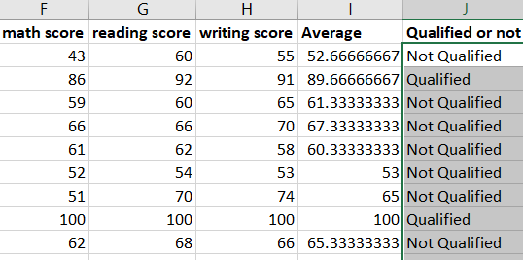

1. **Question:**

Create a new excel file with Revenue and expenses column and calculate the profit. Note that one of the revenue records having a text value and count number of product made profit and number of products end up in loss

**Answer:**

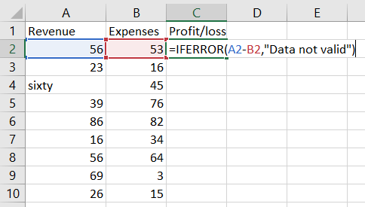 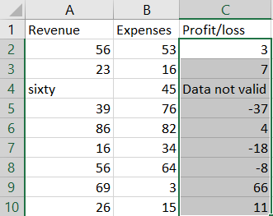

Profit No: =COUNTIF(<profit/loss array>,">0")

Loss No: =COUNTIF(<profit/loss array>,"<0")

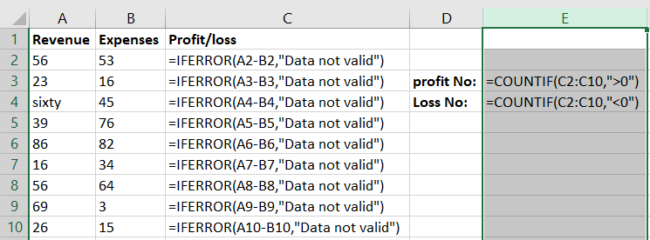 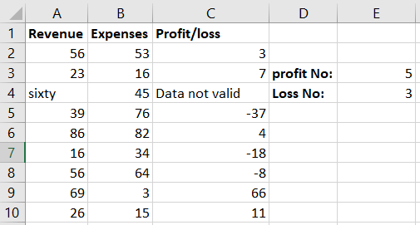

1. **Question:**

Download the data from the given link <https://drive.google.com/file/d/1corzAC8n5bZTmkBxc_vDbUpN5ImiZxuy/view?usp=sharing>

Calculate the total and average of each student and students whose score is more than 65 are qualified and students whose average score less than 65 is not qualified. Find the qualified and not qualified count also

**Answer:**

1. Calculating total:

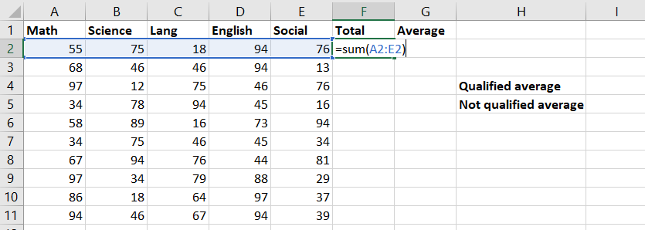

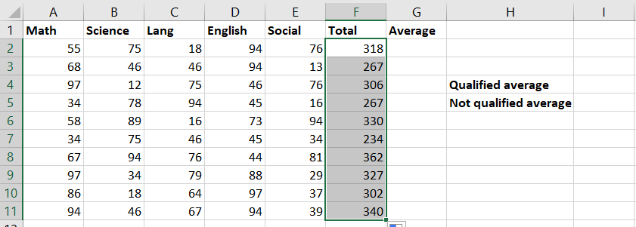

1. Calculating average:

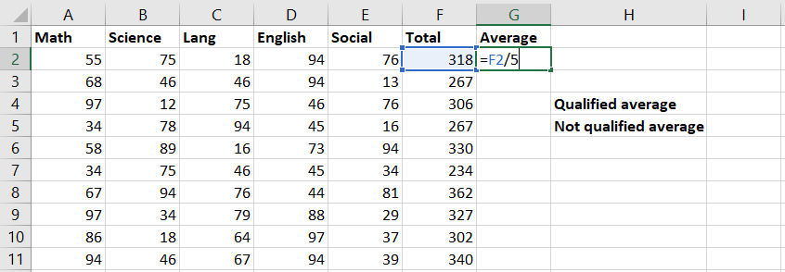

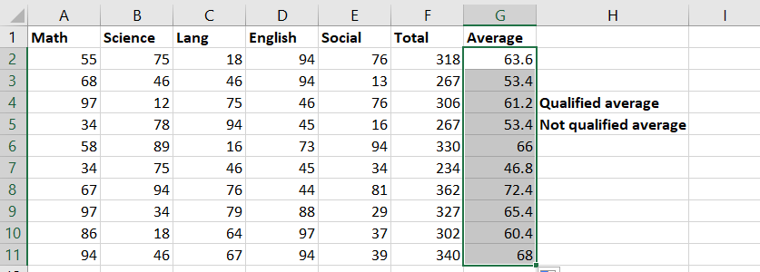

1. Calculating Qualified count:

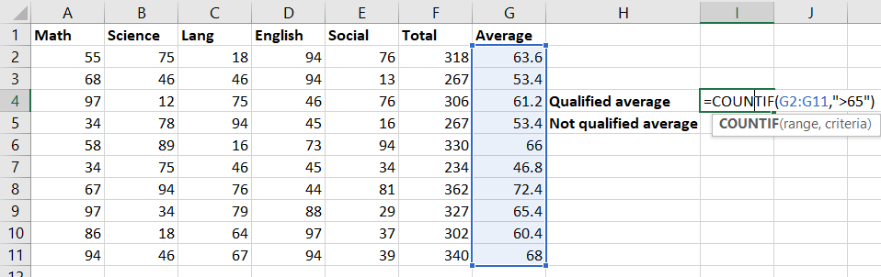

1. Calculating Not Qualified count:

